INTEL INDUSTRIAL SUMMER TRAINING


ANALYSIS ON ACCIDENTS IN INDIAN ROADS AND IDENTIFICATION OF BLACKSPOTS
(STATE : TAMILNADU)

Sai Krishnnan G Pandithurai O Abhishek Nandy
Associate Professor, Asssociate Professor, Industrial Mentor,
Department of Mechnacial Engnieering Department of Computerl Engnieering Intel industrial Summer Training
Rajalakshmi Institute of Technology Rajalakshmi Institute of Technology abisheknandy@theprograms.in
saikrisnan.g@ritchennai.edu.in pandics@ritchennai.edu.in

Jerome Robbins T Jules Nathan Dimanche Kapilan S
Department of Artifical Intellligence Department of Artifical Intellligence Department of Artifical Intellligence
And Data Science And Data Science And Data Science
Rajalakshmi Institute of Technology Rajalakshmi Institute of Technology Rajalakshmi Institute of Technology
jeromerobbins.t.2021.ad@ritchennai.edu.in julesnathandimanche.m.2021.ad@ritchennai.edu.in kapilan.s.2021.ad@ritchennai.edu.in

1. ABSTRACT:
This study deals with identifying the accident blackspots and the influencing factors causing accidents using factored analysis in Tamil Nadu in India. The geospatial technique to identify the blackspots and the factors causing accidents was used for analysis, it was implemented using the QGIS software, power bi. This report was done in according to the research “identifying influencing factors of road accidents in emerging road accident blackspots” in India. This helps in identifying key factors in repetitive accidents and take appropriate measures to reduce the casualties.
Keywords: Black Spots, Road Accidents, QGIS, casualties, power bi.

2.INTRODUCTION:
Road safety is a critical issue in India as accidents on the road network cause significant loss of life and economic losses. the purpose of this report is to explore the concept of black spots and their importance in accident detection and treatment. Understanding the differences that cause black spots is crucial to controlling the transition process. Poor geometry and planning, the number of bends, inadequate markings or the provision of illegal barriers can affect safety. Natural conditions such as poor visibility due to weather conditions cause accidents. Data from 2011-2019 from Tamil Nadu state highways is used

safety. Natural conditions such as poor visibility due to weather conditions or insufficient lighting can cause accidents. we used the data from 2011-2019 Tamil Nadu state highways using the QGIS software to mark the Blackspots from the datasets.

3.LITERATURE SURVEY:
Recently, research has revealed that road crashes causing severe injuries have been identified as a significant public health issue. Hence countermeasures should be initiated to reduce the number of road crashes. It was found that the harsh driving, speeding cause of fatal accidents are 62.9%, 21.4%. accident analysis to identify the severity of vulnerable road users involved in road accidents. The risk factors considered for this study are location, weather condition, road structure. pedestrian.[6] The road accident severity of crash was estimated from the accident data collected for the 14 districts of Kerala, India, for six years from 2014 to 2019. GIS-based accident analysis using the QGIS software to determine the distribution of road accident crashes and identify them. We can conclude that the systematic analysis of accident scenarios with the available data and the implementation of countermeasures such as improved road geometric design, traffic control measures, and effective enforcement could reduce the occurrence of road crashes considerably. By using geospatial analysis, we can improve the efficiency.

4.OBJECTIVE:
- Identify location with high risk of crashes
- Implement methods like geospatial data analysis tool for exploration.
- Represent major accident blackspots in Tamil Nadu.
- Identify contributing factors for blackspots.

5.OUTCOMES:
- Identification of Accident - Prone Locations:
Literature review of the studies provide the area where blackspots occur. These accident-prone locations are identified to get information about the blackspot which occurs in that area.
- Analysis of Contributing Factors:
These conditions include poor construction, poor signage, poor visibility, poor road geometry and poor traffic control.
- Significance of Data-Driven Decision Making:
This study demonstrates the importance of data in decision making for the road safety response. Using accident data and making appropriate analysis, we can provide a precise solution for the blackspots.
- Need for Continuous Monitoring and Evaluation:
The literature review demonstrates the importance of continuous monitoring and evaluation of blackspots and use of security measures.
- Public Perception and Awareness:
Some studies in the scientific literature will explore public and awareness of road safety issues, especially in black spot areas. understanding public attitude help implement the necessary measures.

5.1 FATALITIES DUE TO ROAD ACCIDENTS DISTRICT-WISE USING POWER-BI:
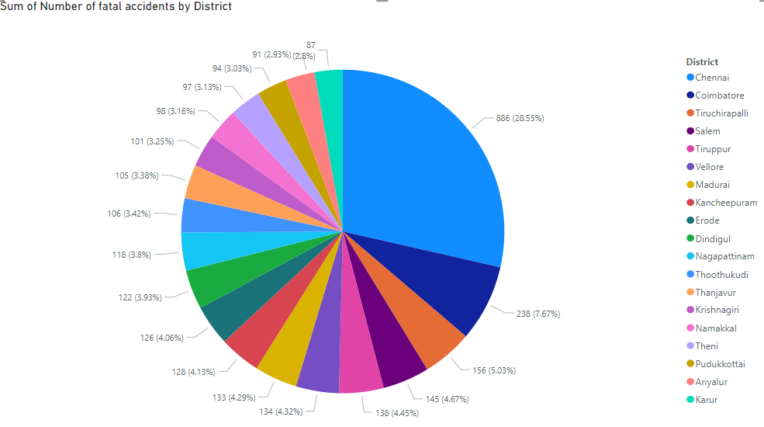
Fig 1.1
The pie chart provides the information about the fatalities which occurred due to road accidents in different districts of Tamil Nadu. It is reported that Chennai is the leading contributor in the accidents. Chennai has the highest number of fatalities contributing to 28.5% of all the accidents which occur in Tamil Nadu, followed by Coimbatore which contributes 7.67% of all the accidents.
5.2 GOOGLE EARTH IMAGE OF BLACKSPOTS IN TAMILNADU:
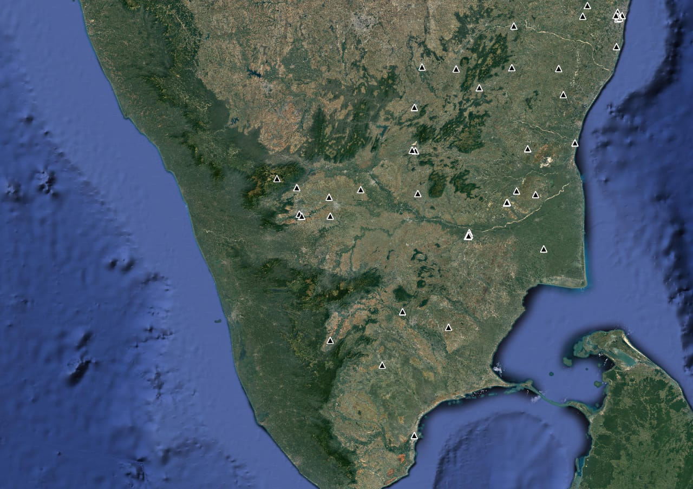
Fig 3.1

6.CHALLENGES:
Researchers and analysts will face some challenges when reporting on blackspots and road safety in Tamil Nadu Below are some of the challenges associated with blackspot identification.
1. Accessibility and quality of Data: One of the main issues is the availability and reliability of accurate data on accidents, road conditions, and contributing factors. In some cases, data may be incomplete, outdated, or inconsistent, making it challenging to complete the full analysis.
2. Data Quality and Standardization: Different sources of data may have different formats, content, and levels of detail. correlating and building the data for analysis can be a time-consuming and complex task, requiring careful data maintenance and prioritization.
3. Lack of Detailed Data: The available data may not cover all relevant variables or provide a complete picture of the blackspots and road safety challenges in Tamil Nadu. Additional information, such as traffic, weather conditions, driver behaviour, and road design details, may be needed for deeper understanding.
4. Complex Spatial and Temporal Analysis: it is difficult to analyze data with a spatial and temporal dimensions Understanding the distribution of accidents and identifying temporal patterns requires specialized techniques and software tools. Taking into Account seasonal variations, traffic flow patterns, and variation added to the complexity to the analysis.
5. Implementation and Monitoring: Translating the findings and recommendations of the report into action can be difficult measures. Implementing safety techniques at blackspots and ensuring their effectiveness require coordination, financial security and regular monitoring and evaluation.
6. Limited Generalizability: Reported findings may have limited applicability to fields or settings. The unique characteristics of Tamil Nadu such as infrastructure, traffic patterns and culture may affect the results, so it is interpreting the findings in local context.

7.ARCHITECTURE MODEL:

STUDY AREA SELECTION

DATA COLLECTION

SURVEY OF IMPORTANT LOCATIONS IN THE STRETCH
ANALYSIS USING THE QGIS SOFTWARE

DETERMINING THE EXACT ACCIDENT LOCATION WITH THE DATA IN MORT&H

BLACK SPOT IDENTIFICATION OF THE STRECTH

8.SOFTWARE MODEL FOR IMPLEMENTATION:
In the report on Blackspots and road safety in Tamil Nadu, QGIS software was used to identify black spots in India and QGIS software was used as a key tool to target Geospatial calculation and visualization.
1. Data Integration and Preparation: QGIS is used to gather information about nature road network, traffic flow and other information about the place. The software helps consolidate and prioritize data from different sources and formats and ensure consistency and create unified data for analysis.
2. Spatial Analysis: QGIS provides geospatial analysis techniques that can be used to analyze data. This includes techniques such as hot spot analysis, spatial clustering, core density estimation, and proximity analysis. This tool can identify and identify black spots as well as discover patterns and relationships
3.Visualization of Blackspots: The graphics and visualization capabilities of QGIS are used to create graphs and representations of black spots and contrast. The software allows customization of symbols, colors, and labels, ensuring that black dot and weight are effectively communicated to readers and stakeholders

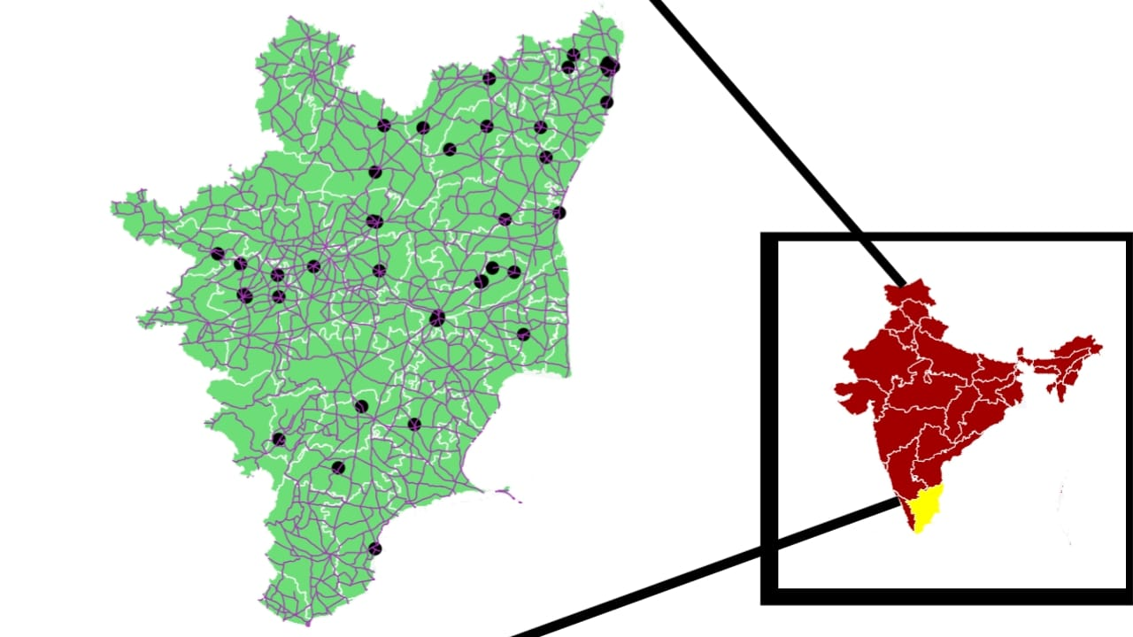
Fig 3.1
4. Overlay and Spatial Queries: QGIS facilitates the overlaying of disparate processes such as environmental data, infrastructure, and social change. This leads to questions and analysis to identify potential black spots such as road conditions, traffic or proximity to certain land uses.
5. Geoprocessing and Spatial Statistics: QGIS provides geoprocessing functions and spatial statistical tools to measure and analyze relationships between variables. This includes calculating distance, area and position statistics such as correlation coefficients or nearest neighbor analysis to understand the properties of black spots.
6. Map Layout and Design: The graphic resources of QGIS are used to create useful images and information about the map. The software allows the creation of map layouts, including legends, scale bars and north arrows, as well as the integration of external graphics or images to enhance the appearance, representation of black spots and related observations.
Overall, QGIS acts as a versatile and powerful software tool that supports data integration, spatial analysis and visualization tasks in media. It allows us to analyze the nature of the situation, detect black spots and gain insight into factors contributing to road safety issues in Tamil Nadu. The report enables geospatial analysis of black spots using QGIS, improves understanding of security issues, and provides interventions and policy recommendations.

8.1 MAJOR BLACKSPOTS IN TAMIL NADU :

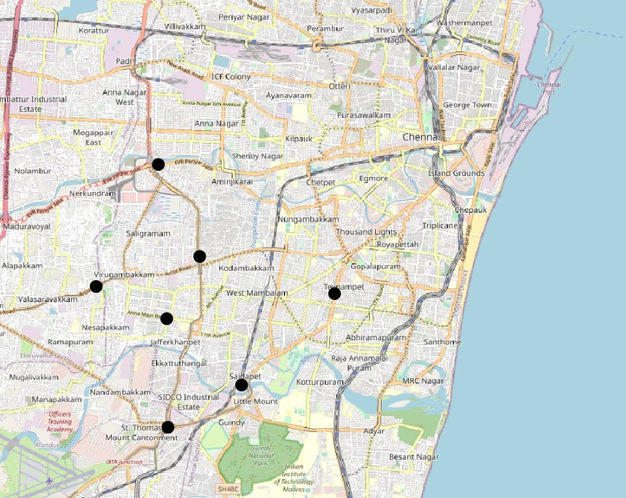
Fig 3.2. blackspots in Chennai
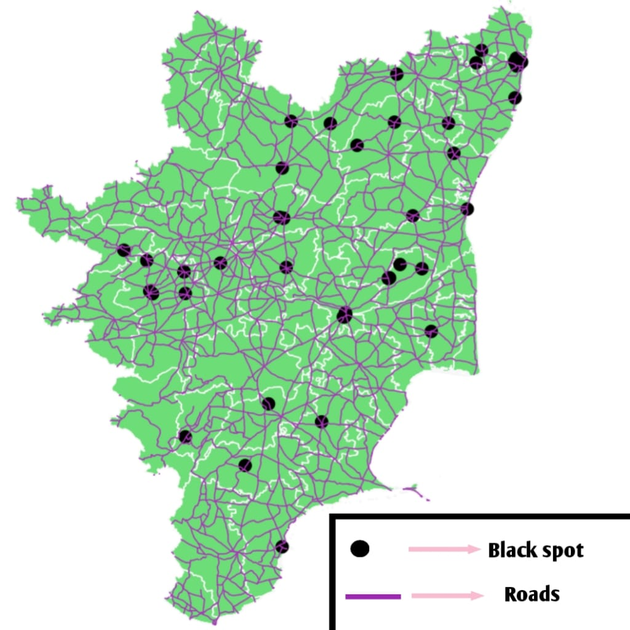
Fig 3.3. Major blackspots in India

9.SOLUTION FOR BLACKSPOTS:
1.Road Design and Infrastructure Improvements: Safety assessment and evaluation of roads and intersections to identify potential black spots. Use engineering measures such as improving road geometry, adding traffic signs, improving pedestrian crossings, and improving visibility to reduce the chance of accidents.
2. Speed Management: Check speed limits in high-risk areas, especially around intersections, crosswalks and eligible road users. Use speed limits such as speed bumps or races to encourage drivers to slow down.
3.Enhanced Signage and Markings: Make sure road signs, traffic signs and pavement markings are clearly visible to guide road users. Improve the visibility of warning signs and instructions in key locations.
4.Road User Education and Awareness: Conduct road safety awareness campaigns to educate drivers, pedestrians and cyclists on safety. Emphasize the importance of responsible behavior, obey traffic rules and avoid distractions while driving.
5.Intelligent Transportation Systems (ITS): Deployment of ITS technologies such as adaptive signal management, collision warnings and traffic cameras to improve traffic management and incident response.

10.CONCLUSION:
In conclusion, the report on blackspots and road safety in Tamil Nadu has employed advanced geospatial analysis techniques by using the QGIS software to provide accurate assessment of the road safety situation. The continuous analysis has successfully identified the high-risk blackspots, characterized by a concentrated occurrence of road accidents. The findings highlight the need for evidence-based decision-making and intervention plans to reduce identified risks. The report highlights the importance of improving signage and pavement markings to improve visibility, enforce traffic laws and raise user awareness. It highlights the need for education campaigns to improve the behavior of road users, including drivers, pedestrians and cyclists, to promote a culture of safety and compliance with the law. The report concludes by recommending the use of data supported by data collection, analysis and monitoring. By implementing a road safety strategy, a safer road can be created in Tamil Nadu and India by reducing the number of accidents and deaths.

11.REFERENCES:
- Kalga R.R, Silanda S.N, “Accident Rate Prediction on Arterial Roads of Durban, South Africa”, Indian Highways Journal, July 2002.
- Baguley Chris, McDonald Mike, et al, “Towards Safer Roads in Developing Countries, A Guide for Planners and Engineers”, Transport Research Laboratory, 1994, pp 1-60
- Prasad, R.R., Suresh, G.L. and Rao, M.Y., 2023, June. Identification, analysis and improvement of accident blackspots: A case study of Narasaraopet Mandal, Andhra Pradesh. In AIP Conference Proceedings (Vol. 2810, No. 1). AIP Publishing.
- Iqbal, A., Rehman, Z.U., Ali, S., Ullah, K. and Ghani, U., 2020. Road traffic accident analysis and identification of black spot locations on highway. Civil Engineering Journal, 6(12), pp.2448-2456.
- S. Mahmoodi Khaniabadi, A. Javadpour, M. Gheisari, W. Zhang, Y. Liu, and A. K. Sangaiah, “An intelligent sustainable efficient transmission internet protocol to switch between User Datagram Protocol and Transmission Control Protocol in IoT computing,” Expert Systems, vol. 2022, Article ID e13129, 2022.
- J. S. K. Ghosh, M. Parida, and J. K. Uraon, “Traffic accident analysis for dehradun city using GIS,” ITPI Journal, vol. 1, no. 3, pp. 40–54, 2004.

